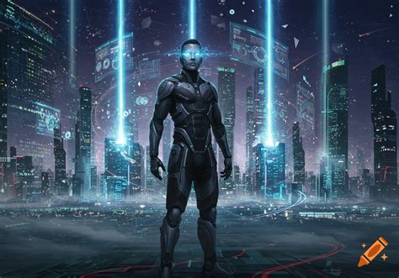
LRN MAN: DEFENDER OF THE NETWORK
Issue #1 — "The Last Son of Maytag"
LRN Man stands heroically in the center wearing a high-tech blue and silver armored suit with a flowing cape and a glowing "LRN" emblem on his chest. He has short hair, a neatly trimmed beard, and rectangular tech-style glasses with a faint digital HUD glow across the lenses. His utility belt is loaded with labeled gadgets: FreeIPA, Splunk, SELinux, Wazuh, CyberArk. He holds a glowing holographic shield in one hand and a pulsing network cable in the other. Behind him, a vast glowing network grid stretches across a city skyline. Cyber threats lurk in the shadows — a red skull representing malware, a hooded hacker figure, rogue drones, and floating malware icons. Binary code rains down from a dark sky.
"PROTECTING EARTH FROM CYBER TERRORISTS!"
Created by Anderson Computer Consulting • Written and designed for the LRN Network Universe

Prologue
"A Signal from the Stars"
Deep in the cosmos, beyond the reach of Earth's most powerful telescopes...

PROLOGUE • PAGE 1

[NARRATION: Deep in the cosmos, beyond the reach of Earth's most powerful telescopes, there exists a world where technology is not just a tool — it is life itself.]

[PANEL 1: FULL PAGE SPLASH]
A breathtaking vista of Planet Maytag — a world of crystalline server towers stretching into violet skies, rivers of liquid data flowing between districts, and massive holographic displays floating above gleaming cities. The planet pulses with blue and white energy. At the center stands The Citadel of Clean Code — the greatest fortress of knowledge in the galaxy.



[NARRATION: Planet Maytag. A civilization built on perfect architecture, unbreakable encryption, and absolute network sovereignty. For ten thousand cycles, the Maytag people thrived — their networks impenetrable, their data sacred, their protocols flawless.]

[PANEL 2:]
Inside the Citadel, the Council of Root Admins — seven robed elders — stand around a holographic star map. Red warning indicators flash across an entire sector. One elder, ELDER SUDO, points at a small blue planet.

ELDER SUDO: "The readings are catastrophic. Planet Earth — their networks are completely exposed. No identity management. No centralized authentication. Their firewalls are... decorative."
ELDER CHMOD: "It is worse than we feared. The Shadow Syndicate has already detected them. Earth will fall within one solar rotation."

[PANEL 3:]
A warrior steps forward from the shadows. He is tall, powerfully built, with short hair, a neatly trimmed beard, and rectangular tech-style glasses that reflect streams of data across their lenses. His piercing blue eyes seem to process information in real time behind those frames. This is LRN — the most brilliant network architect Planet Maytag has ever produced. His armor gleams with embedded circuitry.

LRN: "Then I will go. Give me the Utility Belt of Protocols and access to the Full Stack Arsenal. I will build them a network so secure that even the Shadow Syndicate will break against it like packets against a firewall."
ELDER SUDO: "You understand the risk? Earth's technology is... primitive. You will be working with legacy systems, outdated kernels, and humans who store passwords in plain text."
LRN: "Every network starts with a single packet. I will teach them."

[NARRATION: And so, the last great defender of Maytag loaded the tools of his civilization into a capsule of compressed data, aimed for the blue planet, and launched into the void between stars.]

[PANEL 4: FULL PAGE SPLASH]
LRN's capsule — shaped like a glowing packet of pure encrypted data — streaks across the galaxy, leaving a trail of binary code in its wake. Stars blur around him. The blue dot of Earth grows larger.

WHOOOOOOSH!

— — — PAGE BREAK — — —

Chapter 1
"Arrival: First Boot"
Earth. A world of seven billion souls connected by networks they barely understand.

CHAPTER 1 • PAGE 1

[NARRATION: Earth. A world of seven billion souls connected by networks they barely understand — and cannot protect.]

[PANEL 1: WIDE SHOT]
Night sky over a sprawling modern city. A streak of blue light tears across the darkness like a comet. Car alarms trigger. Dogs bark. People point at the sky.

BYSTANDER 1: "Is that a meteor?!"
BYSTANDER 2: "No... it's slowing down!"

[PANEL 2:]
The capsule crashes into an empty server farm parking lot, cratering the asphalt. Steam and digital particles rise from the impact zone. Emergency lights flicker.

KRRRA-KOOOM!

[PANEL 3:]
LRN Man emerges from the crater, standing tall. His suit reconfigures around him — the blue and silver armor locking into place, the cape unfurling behind him, the LRN emblem igniting on his chest. His short hair is swept back, his trimmed beard sharp and defined, and his rectangular tech-style glasses gleam with HUD data overlays streaming across the lenses. His utility belt materializes, each compartment labeled and glowing: FreeIPA, SELinux, Firewall, Splunk, Graylog, Wazuh, CyberArk, LDAP, TLS/SSL, Rapid7, Nipper, CMMD, GitLab, Cockpit, SBAI, Bind 9, DogTag, Certificates, Kerberos, Slapd, SSSD, AIDE, Retina Scanners, Tokens.

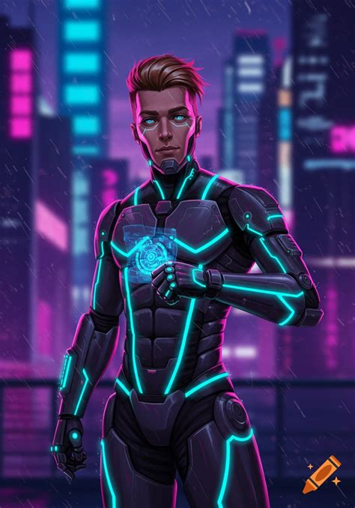
LRN MAN: "First boot complete. Scanning local network topology..."

[NARRATION: His glasses lit up with data — and what he saw horrified him.]

[PANEL 4: LRN MAN'S HUD VIEW]
Through his glasses, we see a nightmarish visualization of Earth's networks: open ports everywhere like gaping wounds, unencrypted traffic flowing like blood, default passwords blinking in red, and dark shadowy tendrils of malware creeping through systems. A counter reads: "CRITICAL VULNERABILITIES DETECTED: 4,271,553,902"

LRN MAN: "By the Root Admins of Maytag... it's worse than the Council feared. These networks are completely naked. No identity governance. No certificate authority. DNS is... unsecured. This planet is a buffet for every cyber predator in the galaxy."

— — — PAGE BREAK — — —
CHAPTER 1 • PAGE 2

[PANEL 1:]
LRN Man touches the ground, and blue circuit patterns spread outward from his hand like veins through the earth, scanning the infrastructure beneath the city. The glow of the circuit patterns reflects off his glasses and the silver trim of his armor.

LRN MAN: "I need a base of operations. Somewhere with power, connectivity, and enough rack space for what I'm about to build."

[PANEL 2:]
He locates an abandoned underground data center — a massive bunker beneath the city with rows of dead servers and dusty fiber runs. LRN Man's glasses glow brighter as their HUD scans and maps the space.

LRN MAN: "This will do. Time to build the most secure network this planet has ever seen."

[NARRATION: And so began the greatest infrastructure project in Earth's history. What took the people of Maytag a thousand cycles, LRN Man would accomplish in days. Because the enemy was already here.]

[PANEL 3: OMINOUS CUTAWAY]
In a dark room somewhere across the world, banks of screens glow red. A figure sits in shadow — THE ZERO-DAY KING, leader of the Shadow Syndicate's Earth operations. His face is half-metal, half-scarred flesh. Code scrolls across his cybernetic eye.

ZERO-DAY KING: "Something just landed. Something... powerful. I felt the network shift. Find it. Kill it. Before it secures even a single subnet."
HENCHMAN (PACKET SNIFFER): "Already on it, boss. Deploying reconnaissance malware across all ISPs."

— — — PAGE BREAK — — —

Chapter 2
"The Foundation: Identity and Trust"
Every great fortress begins with a foundation — and in the digital world, that foundation is identity.

CHAPTER 2 • PAGE 3

[NARRATION: Day One. Every great fortress begins with a foundation — and in the digital world, that foundation is identity. Who are you? Can you prove it? LRN Man would accept nothing less than absolute certainty.]

[PANEL 1: WIDE ESTABLISHING SHOT]
The underground data center is transforming. LRN Man works at superhuman speed, racks lighting up one by one. Holographic blueprints float around him showing network diagrams, authentication flows, and certificate chains. Data streams reflect across his rectangular glasses as he orchestrates the build.

LRN MAN: "First rule of network defense: if you don't control identity, you control nothing."

[PANEL 2:]
LRN Man reaches for the first compartment on his utility belt — it glows with golden light. He pulls out a crystalline device labeled
FreeIPA
.

LRN MAN: "FreeIPA — the cornerstone. Centralized identity management, policy enforcement, and authentication. Every user, every machine, every service — all verified through a single source of truth."

[NARRATION: He deployed FreeIPA like a master architect laying the first stone of an unbreakable citadel. User accounts, host registrations, role-based access controls, and sudo policies flowed into existence.]

[PANEL 3:]
With a wave of his hand, LRN Man activates
Kerberos
— depicted as a three-headed digital guardian dog materializing above the servers, each head watching a different network zone.

LRN MAN: "Kerberos — the three-headed guardian of authentication. Ticket-granting tickets, session keys, mutual verification. No one accesses this network without proving exactly who they are."

[PANEL 4:]
He reaches for another tool —
LDAP
and
Slapd
— twin devices that merge into a massive glowing directory tree that spreads through the infrastructure like a nervous system.

LRN MAN: "LDAP and Slapd — the directory backbone. Every object, every attribute, every organizational unit — structured, searchable, and locked down with access control lists."

— — — PAGE BREAK — — —
CHAPTER 2 • PAGE 4

[PANEL 1:]
LRN Man activates
SSSD
— depicted as a shimmering mesh that connects all endpoints to the identity infrastructure, creating seamless authentication even when connectivity wavers.

LRN MAN: "SSSD — the System Security Services Daemon. Cached credentials, offline authentication, multi-domain identity lookups. Even if the network blinks, authentication never fails."

[PANEL 2:]
Next comes
DogTag
— LRN Man produces a glowing forge from his belt and begins minting digital certificates like a blacksmith forging armor.

LRN MAN: "DogTag Certificate System — my own Certificate Authority. X.509 certificates for every server, every service, every user. No unsigned connections. No untrusted handshakes. Every bit of data wrapped in cryptographic proof."

[PANEL 3:]
He layers on
TLS
and
SSL
— depicted as shimmering energy shields wrapping around every data stream, turning exposed traffic into impenetrable encrypted tunnels.

LRN MAN: "TLS and SSL — encrypted channels for every connection. The days of plaintext are over on this planet."

[PANEL 4:]
Finally, he deploys
AIDE
(Advanced Intrusion Detection Environment) — visualized as thousands of tiny sentinel drones that attach to every file and directory, memorizing their exact state.

LRN MAN: "AIDE — my tripwire. Every file checksummed, every directory baselined. If even a single byte changes without authorization, I'll know instantly."

[NARRATION: In twelve hours, LRN Man had built an identity infrastructure that would take Earth's best engineers years to design. But identity was only the foundation. The walls and weapons were next.]

— — — PAGE BREAK — — —

Chapter 3
"The Walls: Hardening and Perimeter Defense"
Every fortress needs walls. His would be impenetrable.

CHAPTER 3 • PAGE 5

[NARRATION: With identity established, LRN Man turned to the perimeter — the boundary between the protected network and the chaos beyond. Every fortress needs walls. His would be impenetrable.]

[PANEL 1: DRAMATIC WIDE SHOT]
LRN Man stands atop his data center, arms raised, his cape billowing behind him. The light of the rising digital walls reflects off his glasses and illuminates his trimmed beard. Around the entire network, massive digital walls begin rising — layer upon layer of firewalls, policies, and enforcement mechanisms.

[PANEL 2:]
He activates
SELinux
— depicted as a suit of Mandatory Access Control armor that wraps around every server and process, enforcing strict security policies at the kernel level.

LRN MAN: "SELinux — Mandatory Access Control at the kernel level. Every process confined. Every file labeled. Every action checked against policy. Even if an attacker gets in, they can't move. They can't escalate. They can't breathe."

[NARRATION: Where other defenders left SELinux in permissive mode — afraid of its power — LRN Man set it to ENFORCING. No exceptions. No compromises.]

[PANEL 3:]
Next, the
Firewalls
— LRN Man constructs a multi-layered firewall architecture depicted as towering walls of blue energy with inspection gates at every tier.

LRN MAN: "Layered firewall architecture — perimeter, internal segmentation, host-based. Every packet inspected. Every connection statefully tracked. Default deny. If I didn't explicitly permit it, it doesn't pass."

[PANEL 4:]
He deploys
Bind 9
— the DNS infrastructure materializes as a massive map of the network, translating names to addresses with cryptographic DNSSEC signatures protecting every query.

LRN MAN: "Bind 9 — authoritative DNS under my control. DNSSEC-signed zones, split-horizon configurations, rate limiting, and response policy zones. The DNS is the nervous system of any network — and mine is armored."

— — — PAGE BREAK — — —
CHAPTER 3 • PAGE 6

[PANEL 1:]
LRN Man reaches for the authentication enhancement tools on his belt —
Retina Scanners
and
Tokens
materialize as physical security devices that integrate with the digital infrastructure.

LRN MAN: "Multi-factor authentication — something you know, something you have, something you ARE. Retina scanners for biometric verification. Hardware tokens for cryptographic proof of possession. Passwords alone are relics of a primitive age."

[PANEL 2:]
He activates
CyberArk
— depicted as an enormous, gleaming digital vault that rises from the floor, its door inscribed with rotating encryption keys.

LRN MAN: "CyberArk — Privileged Access Management. Every admin credential, every service account, every root password — rotated, vaulted, audited, and session-recorded. No one touches a privileged account without going through the vault."

[PANEL 3:]
Nipper
appears as a scanning device that LRN Man runs across every network device — routers, switches, firewalls — producing detailed compliance reports.

LRN MAN: "Nipper — configuration audit for every network device. CIS benchmarks, DISA STIGs, vendor hardening guides. Every switch, router, and firewall checked against the gold standard. No misconfigurations survive."

[NARRATION: The walls were rising. Layer by layer, the network transformed from an open field into a fortress of overlapping defenses. But LRN Man knew — walls alone cannot protect you. You need eyes.]

— — — PAGE BREAK — — —

Chapter 4
"The Watchtowers: Monitoring and Detection"
A fortress without sentries is just a tomb waiting to be raided.

CHAPTER 4 • PAGE 7

[NARRATION: A fortress without sentries is just a tomb waiting to be raided. LRN Man's next move was to give the network the one thing it lacked most — visibility. Total, absolute, inescapable visibility.]

[PANEL 1: CINEMATIC WIDE SHOT]
LRN Man stands in a newly constructed command center — a circular room with wraparound holographic displays showing every corner of the network in real time. Data streams flow like rivers of light, their glow reflecting across his glasses and illuminating his confident expression.

LRN MAN: "Now we build the watchtowers."

[PANEL 2:]
He deploys
Splunk
— depicted as a massive all-seeing eye that opens above the command center, its iris made of swirling log data from every system.

LRN MAN: "Splunk — the Eye of the Network. Every log, every event, every anomaly from every system aggregated, correlated, and analyzed in real time. Custom dashboards, alerting rules, and machine learning models that spot threats humans would miss."

[PANEL 3:]
Next comes
Graylog
— visualized as a vast library of scrolling data, with automated processors sorting and categorizing every message.

LRN MAN: "Graylog — centralized log management. Structured logging, pipeline processing, and alerting. Redundancy for Splunk. Because one set of eyes is never enough."

[PANEL 4:]
Wazuh
materializes as an army of digital agents that deploy to every endpoint, each one a miniature guardian scanning for threats.

LRN MAN: "Wazuh — host-based intrusion detection on every endpoint. File integrity monitoring, rootkit detection, compliance checking, and active response. Every server has a guardian standing watch."

— — — PAGE BREAK — — —
CHAPTER 4 • PAGE 8

[PANEL 1:]
Rapid7
deploys as a fleet of scanner drones that sweep across the network, probing every system for vulnerabilities and mapping the attack surface.

LRN MAN: "Rapid7 — vulnerability management. Continuous scanning, risk scoring, prioritized remediation. I know every weakness in this network before any attacker does — and I fix them before they can be exploited."

[PANEL 2:]
LRN Man surveys all four monitoring systems working in concert — Splunk, Graylog, Wazuh, and Rapid7 — their data feeds interweaving into a unified threat picture on the command center's main display.

LRN MAN: "Four watchtowers. Four perspectives. Overlapping fields of vision. Nothing enters this network, nothing moves within it, nothing leaves it — without me knowing."

[NARRATION: The network now had eyes — thousands of them, watching every packet, every process, every login, every file change. But LRN Man wasn't done. A defender who only watches and waits will eventually be overwhelmed. He needed the power to respond at machine speed.]

— — — PAGE BREAK — — —

Chapter 5
"The Arsenal: Automation and Deployment"
The difference between victory and catastrophe is measured in milliseconds.

CHAPTER 5 • PAGE 9

[NARRATION: Speed. In cyber warfare, the difference between victory and catastrophe is measured in milliseconds. LRN Man needed to respond, deploy, patch, and adapt faster than any human operator could. He needed automation.]

[PANEL 1:]
LRN Man opens the automation compartment on his utility belt.
GitLab
emerges as a massive version-controlled codex — every configuration, every script, every policy stored, tracked, and deployable.

LRN MAN: "GitLab — Infrastructure as Code. Every configuration file, every automation playbook, every security policy version-controlled. Peer-reviewed. CI/CD pipelines that deploy hardened configurations across the entire network in seconds."

[PANEL 2:]
Cockpit
materializes as a sleek command interface that overlays every server, giving LRN Man single-pane-of-glass management across the infrastructure.

LRN MAN: "Cockpit — web-based server management. Real-time performance metrics, service control, log viewing, and terminal access from a unified dashboard. Every server, one interface."

[PANEL 3:]
CMMD
(Configuration Management and Mass Deployment) activates as a wave of energy that synchronizes configurations across thousands of systems simultaneously.

LRN MAN: "CMMD — mass deployment and configuration management at scale. One command to patch a thousand servers. One push to enforce a new security baseline across the entire fleet. Consistency is security."

[PANEL 4:]
SBAI
(Security Baseline Automation and Intelligence) activates as an AI co-processor embedded in LRN Man's suit, providing real-time threat intelligence and automated response recommendations. Data feeds stream across the HUD in his glasses.

LRN MAN: "SBAI — Security Baseline Automation Intelligence. My AI co-processor. Threat intelligence feeds, automated baseline enforcement, and predictive analytics. It learns. It adapts. It never sleeps."

[NARRATION: With automation in place, the network became a living organism — self-healing, self-monitoring, self-defending. What would take an army of engineers to manage, LRN Man controlled with a thought. The fortress was complete. And just in time.]

— — — PAGE BREAK — — —

Chapter 6
"The Siege: Shadow Syndicate Attacks"
They came in the dark hours — a coordinated assault from every direction.

CHAPTER 6 • PAGE 10

[NARRATION: They came in the dark hours — a coordinated assault from every direction, every vector, every layer of the stack. The Shadow Syndicate had found Earth's new defender, and they brought everything they had.]

[PANEL 1: FULL PAGE SPLASH — THE ATTACK BEGINS]
The sky above the city turns blood-red with digital distortion. Massive holographic skulls materialize above the skyline. The Zero-Day King stands atop a tower of corrupted data, his army spread before him — Packet Sniffer, Ransomware Queen, the Brute Force Brothers, and thousands of bot-net soldiers.


ZERO-DAY KING: "BRING DOWN HIS PRECIOUS NETWORK! OVERWHELM HIS FIREWALLS! EXPLOIT EVERY VULNERABILITY! TONIGHT, EARTH'S NETWORKS FALL — AND THIS 'LRN MAN' FALLS WITH THEM!"
DOOM DOOM DOOM

— — — PAGE BREAK — — —
CHAPTER 6 • PAGE 11

[NARRATION: Wave One — The DDoS tsunami.]

[PANEL 1:]
A massive wall of bot-net traffic — depicted as a tidal wave of corrupted packets — crashes against the outer firewall perimeter. The firewalls strain, glow red, but hold.

KRAAAASH!

[PANEL 2:]
LRN Man stands calmly in his command center, monitoring the assault. Alert data scrolls rapidly across his rectangular glasses. Splunk dashboards light up with alerts. Wazuh agents report across every endpoint. Graylog processes surge.

LRN MAN: "DDoS attack — 4.7 terabits per second across 200,000 bot-net nodes. Impressive. Deploying rate limiting, geo-blocking, and traffic scrubbing. Firewalls — adaptive mode."

[PANEL 3:]
The firewalls respond — depicted as the energy walls shifting, adapting, absorbing the traffic and redirecting it into sinkholes. The DDoS wave breaks apart.

[NARRATION: Wave Two — Social engineering and phishing.]

[PANEL 4:]
The Ransomware Queen launches thousands of phishing emails — depicted as poison-tipped arrows raining down on users. But LRN Man's email security and user training programs activate — shields appear over every user terminal.

LRN MAN: "Phishing attempt detected across 47,000 endpoints. Email filtering engaged. DMARC, SPF, and DKIM verification active. Users trained. Quarantine protocols executing."

— — — PAGE BREAK — — —
CHAPTER 6 • PAGE 12

[NARRATION: Wave Three — The Zero-Day exploit.]

[PANEL 1:]
The Zero-Day King himself steps forward, holding a glowing red orb — a never-before-seen exploit designed to bypass all known defenses. He hurls it at the network.

ZERO-DAY KING: "Let's see your precious tools stop THIS, LRN Man! A custom zero-day — crafted specifically for your infrastructure. No signature. No patch. No defense."

[PANEL 2:]
The exploit penetrates the outer perimeter — but SELinux activates immediately. The process is confined. Mandatory Access Control locks it in a sandbox. It can't move laterally. It can't escalate.

LRN MAN: "SELinux — enforcing mode. Your exploit made it past the wall — but it's in a cage now. Confined. Contained. Powerless."

[PANEL 3:]
Wazuh detects the file changes. AIDE confirms integrity violation. Splunk correlates the anomaly. Rapid7 identifies the vulnerability vector. All four systems converge on the threat in milliseconds.

LRN MAN: "Four watchtowers. All seeing the same thing. Triangulated. Identified. Now — AIDE shows me exactly what changed, Wazuh shows me the process tree, Splunk gives me the timeline, and Rapid7 maps the attack vector."

[PANEL 4:]
LRN Man reaches for CyberArk — all privileged credentials rotate simultaneously. Kerberos invalidates all existing tickets and reissues. DogTag revokes compromised certificates and mints new ones.

LRN MAN: "CyberArk — emergency credential rotation! Kerberos — ticket invalidation! DogTag — certificate revocation and reissuance! Even if they captured credentials, they're worthless now. Every key just changed."
KLIK-KLIK-KLIK-KLIK!

— — — PAGE BREAK — — —

Chapter 7
"The Counterattack"
Defense wins battles. But offense wins wars.

CHAPTER 7 • PAGE 13

[NARRATION: Defense wins battles. But offense wins wars. LRN Man was done absorbing hits. It was time to strike back.]

[PANEL 1: DRAMATIC POSE]
LRN Man steps out of the command center onto the digital battlefield. His suit pulses with energy, his cape flaring behind him. His short hair catches the glow of the network, his trimmed beard framing a determined jaw, and his rectangular glasses blazing with streaming HUD data. Every tool on his belt glows simultaneously. Behind him, the network infrastructure hums with perfect health — a digital fortress of blinding light.

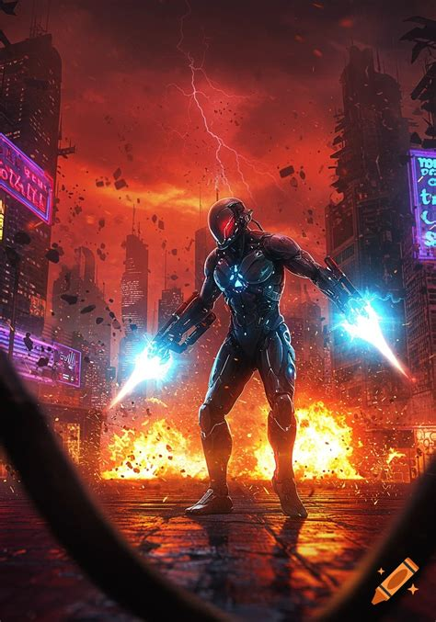
LRN MAN: "You came to my network. You attacked my systems. You threatened my planet. Now let me show you what a Maytag-trained Network Defender can do."

[PANEL 2:]
LRN Man uses
GitLab
to push a massive automated response — honeypots deploy across the network, luring the Syndicate's attackers into traps where their tools are analyzed and neutralized.

LRN MAN: "GitLab pipeline — deploying honeypot infrastructure. Come on in, Syndicate. Show me your tools. I'll catalog every one of them."

[PANEL 3:]
Cockpit
gives him real-time visibility as he surgically isolates compromised segments, reroutes clean traffic, and maintains service availability throughout the battle.

LRN MAN: "Cockpit — surgical network segmentation. Isolating infected VLANs, rerouting production traffic. Users won't even know there's a war happening."

[PANEL 4:]
SBAI
identifies the Syndicate's command-and-control infrastructure.
Bind 9
manipulates DNS to sinkhole their C2 domains. The Syndicate's communication network collapses.

LRN MAN: "SBAI identified your C2 servers. Bind 9 — DNS sinkhole engaged. Your army just lost contact with their generals."
BZZZZZT!

— — — PAGE BREAK — — —
CHAPTER 7 • PAGE 14

[PANEL 1:]
The Brute Force Brothers — two massive digital thugs — charge at the authentication systems, hammering passwords at billions of attempts per second. Kerberos and FreeIPA hold firm. Account lockouts trigger. Retina scanners and tokens block every attempt.

BRUTE FORCE BROTHER 1: "RRRAAAGH! WHY WON'T IT BREAK?!"
LRN MAN: "Because it's not just passwords anymore, you Neanderthals. It's Kerberos tickets. FreeIPA policies. Multi-factor with biometrics and hardware tokens. You could brute-force until the heat death of the universe and never get in."

[PANEL 2:]
Packet Sniffer tries to intercept traffic — but every stream is wrapped in TLS/SSL encryption. His tools return nothing but encrypted gibberish.

PACKET SNIFFER: "I can't read anything! It's all encrypted! Every single connection!"
LRN MAN: "TLS everywhere. Certificate-pinned. Perfect forward secrecy. Your sniffer is useless here."

[PANEL 3:]
The Ransomware Queen deploys her payload — but AIDE detects the file changes instantly, Wazuh triggers active response, and CMMD pushes clean configurations from GitLab, wiping the ransomware before it can encrypt a single file.

RANSOMWARE QUEEN: "NO! My beautiful ransomware! It's being... overwritten?!"
LRN MAN: "CMMD restored from GitLab within 0.3 seconds. Your ransomware never had a chance. Every system baselined. Every configuration version-controlled. You can't corrupt what I can rebuild in milliseconds."

[PANEL 4: THE FINAL CONFRONTATION]
LRN Man faces the Zero-Day King directly on the digital battlefield. The two stand on opposite sides of a glowing network grid — hero and villain. LRN Man's glasses flash with tactical data, his trimmed beard set against a clenched jaw, his cape rippling with digital energy.

ZERO-DAY KING: "You may have stopped my army. But I am the Zero-Day King. I find the vulnerabilities no one else can see. Every system has a flaw. Even yours."
LRN MAN: "Every system has potential flaws. The difference is — I hunt them before you do. Rapid7 scans continuously. Nipper audits every device. SBAI models threats predictively. And when you DO find a zero-day? SELinux contains it. Wazuh detects it. My automation patches it. You're not fighting a man, Zero-Day King. You're fighting a SYSTEM."

— — — PAGE BREAK — — —

Chapter 8
"The Network Stands"
THIS IS MY NETWORK. AND I DEFEND IT.

CHAPTER 8 • PAGE 15

[PANEL 1: EPIC FULL-PAGE SPLASH]
LRN Man raises both hands, his short hair swept back, his trimmed beard sharp in the blazing light, his rectangular tech-style glasses ablaze with cascading data from every system. His cape surges behind him. Every tool from his belt activates simultaneously — FreeIPA, SELinux, Kerberos, LDAP, Slapd, SSSD, Bind 9, DogTag, CyberArk, Splunk, Graylog, Wazuh, Rapid7, Nipper, AIDE, GitLab, Cockpit, CMMD, SBAI, TLS, SSL, Certificates, Retina Scanners, Tokens, Firewalls — all converge into a single unified defense matrix. A massive dome of interlocking security layers envelops the entire network.

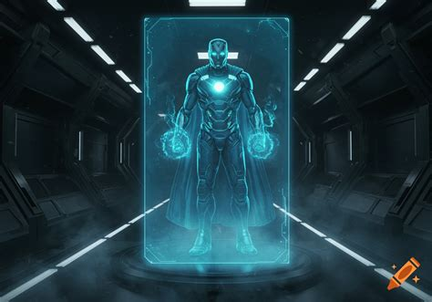
LRN MAN: "THIS IS MY NETWORK. AND I DEFEND IT."
KRAKOOOOOOM!

[PANEL 2:]
The unified defense matrix pulses outward, sweeping through every system, every endpoint, every connection — purging malware, closing exploits, blocking attackers, and restoring integrity. The Shadow Syndicate's forces dissolve like corrupted data being overwritten.

ZERO-DAY KING: "IMPOSSIBLE! No single defender can—"
LRN MAN: "I'm not a single defender. I'm every tool, every protocol, every policy working as one. That's what you never understood. Security isn't a product — it's an architecture."

[PANEL 3:]
The Zero-Day King's avatar cracks, fragments, and disintegrates. His connection severed. His exploits neutralized. His army scattered. The red sky clears, replaced by clean blue and flowing data streams.

[NARRATION: The Shadow Syndicate retreated to the darkest corners of the darknet, their attack shattered against the most secure network Earth had ever known. The Zero-Day King would return — they always do. But LRN Man would be waiting.]

— — — PAGE BREAK — — —
EPILOGUE • PAGE 16

[PANEL 1: PEACEFUL WIDE SHOT]
Dawn breaks over the city. The network hums quietly, perfectly. Splunk dashboards show all green. Wazuh reports zero threats. AIDE confirms full integrity. The digital world is at peace — for now.

[NARRATION: In the days that followed, the world began to notice. Networks that once bled data now stood firm. Systems that once fell to script kiddies now repelled nation-state attacks. And somewhere beneath the city, a defender from another world watched over it all.]

[PANEL 2:]
LRN Man sits in his command center, monitoring feeds from around the globe. The glow of the holographic displays reflects softly off his rectangular glasses and the silver trim of his armor. New FreeIPA domains coming online. New Kerberos realms. New certificate authorities. The security infrastructure is spreading — growing — evolving.

LRN MAN: "One network at a time. One subnet at a time. One system at a time. That's how you secure a planet."

[PANEL 3:]
He looks up at a holographic display showing Planet Maytag, far away in the stars. A small smile crosses his bearded face, the light of his home world glinting off his glasses.

LRN MAN: "The Council was right to send me. These humans — they're messy, chaotic, and they still click on phishing links. But they're worth protecting. And I'll be here as long as they need me."

[NARRATION: He is the last son of Maytag. The architect of the unbreakable network. The guardian who never sleeps, never rests, and never lets a single malicious packet pass unchallenged.]

[NARRATION: He is LRN Man — Defender of the Network.]

[FINAL PANEL: FULL PAGE]
LRN Man stands silhouetted against the glowing network grid, cape flowing, utility belt gleaming, the LRN emblem burning bright on his chest. His short hair, trimmed beard, and rectangular tech-style glasses are outlined by the radiant glow behind him. Behind him, the city sleeps safely. Above him, stars twinkle — including the distant light of Planet Maytag.

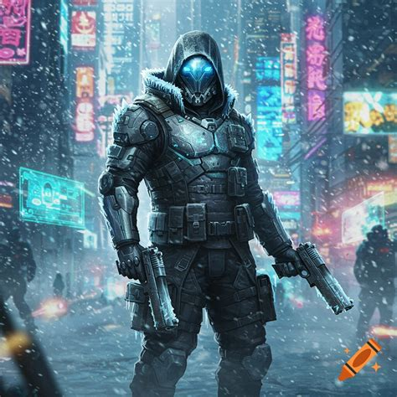

THE NETWORK STANDS. BUT THE THREATS NEVER STOP.
LRN MAN WILL RETURN IN ISSUE #2: "THE RANSOMWARE WARS"
"PROTECTING EARTH FROM CYBER TERRORISTS — ONE PACKET AT A TIME."

— — — PAGE BREAK — — —

LRN MAN'S UTILITY BELT

FIELD GUIDE — CLASSIFIED TECH MANUAL

Clearance Level: ROOT • Classification: MAYTAG COUNCIL EYES ONLY • Revision: 1.0

IDENTITY & AUTHENTICATION

Tool | Classification
FreeIPA | Centralized identity management, authentication, and policy enforcement
Kerberos | Network authentication protocol using ticket-based verification
LDAP | Lightweight Directory Access Protocol for directory services
Slapd | OpenLDAP server daemon for directory services
SSSD | System Security Services Daemon for identity and authentication
Retina Scanners | Biometric authentication for physical and logical access
Tokens | Hardware security tokens for multi-factor authentication

ENCRYPTION & CERTIFICATES

Tool | Classification
DogTag | Certificate Authority and PKI management system
TLS/SSL | Transport Layer Security for encrypted communications
Certificates | X.509 digital certificates for authentication and encryption
CyberArk | Privileged Access Management and credential vaulting

HARDENING & PERIMETER DEFENSE

Tool | Classification
SELinux | Mandatory Access Control enforcement at the kernel level
Firewalls | Multi-layered perimeter and internal network defense
Bind 9 | Authoritative DNS server with DNSSEC support
Nipper | Network device configuration auditing and compliance

MONITORING & DETECTION

Tool | Classification
Splunk | Security Information and Event Management (SIEM) and log analytics
Graylog | Centralized log management and alerting platform
Wazuh | Host-based intrusion detection and endpoint security
Rapid7 | Vulnerability management and penetration testing
AIDE | Advanced Intrusion Detection Environment for file integrity monitoring

AUTOMATION & DEPLOYMENT

Tool | Classification
GitLab | Version control, CI/CD, and Infrastructure as Code
Cockpit | Web-based Linux server management interface
CMMD | Configuration Management and Mass Deployment
SBAI | Security Baseline Automation and Intelligence

— — — PAGE BREAK — — —

CREDITS
LRN MAN: DEFENDER OF THE NETWORK
Issue #1 — "The Last Son of Maytag"

Created by Anderson Computer Consulting
Part of the LRN Network Universe
"Security Is Not a Product — It Is an Architecture."
© Anderson Computer Consulting. All rights reserved.

